NOTE: If you did any changes recently (which are not submitted) Take that routines as a backup

* Click right button of mouse on ocean-lbg (check below screen shot) and select Reset

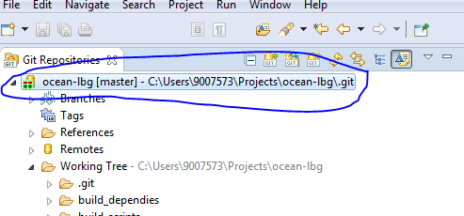

* Select origin/master under remote tracking. (check below screen shot)
* Check Hard
* Click on Reset

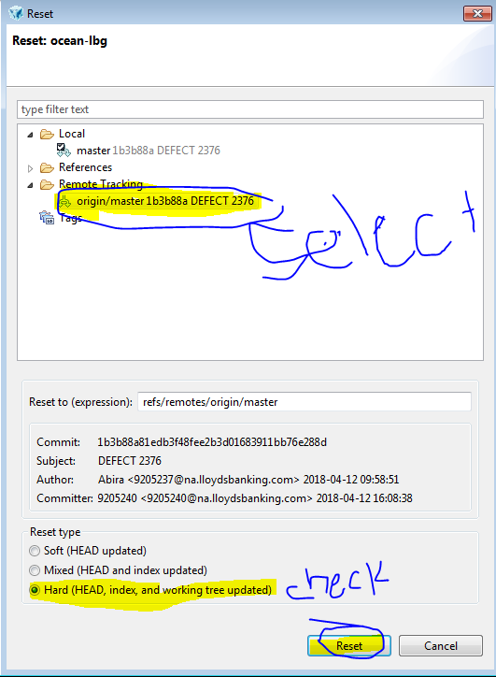

* Click yes on popup window (check below screen shot)

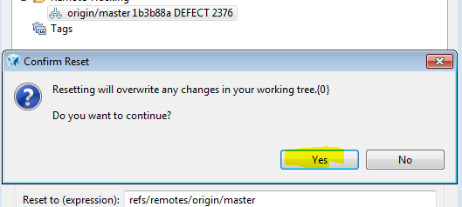

* Click right button of mouse on ocean-lbg (check below screen shot) and select Reset



* Select HEAD under Reference. (check below screen shot)
* Check Hard
* Click on Reset

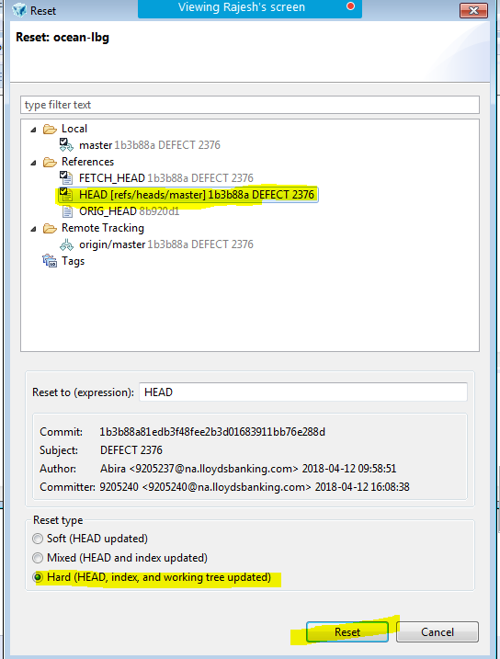

* Click yes on popup window (check below screen shot)



* Click right button of mouse on ocean-lbg (check below screen shot) and select Clean



* Select files which you don’t want. then click finish and click ok if pop window display.
* Otherwise cancel

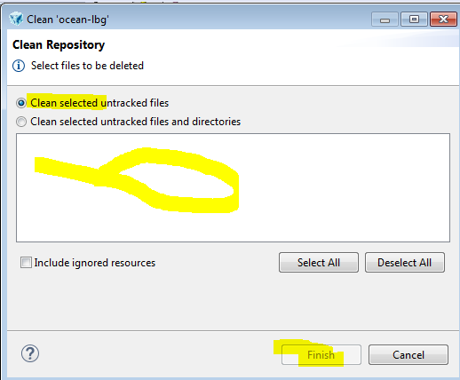

* Do git Fetch & Rebase
* Do changes on routines what you want and push those to gerrit.